Practical No. 5

Aim: Implement the attach window activity, Automate using Anchor Base, Automate using Element Exists.

1. Implement the attach window activity, Automate using Anchor Base, Automate using Element Exists.
   1. **Open Browser** – Launch Google Chrome and navigate to the given URL.
   2. **Check App State** – Verify if the "Images" tab element is present on the page.
   3. **If Target Appears** – Show message box: "Target has appeared".
   4. **If Target Does Not Appear** – Show message box: "Target did not appear".

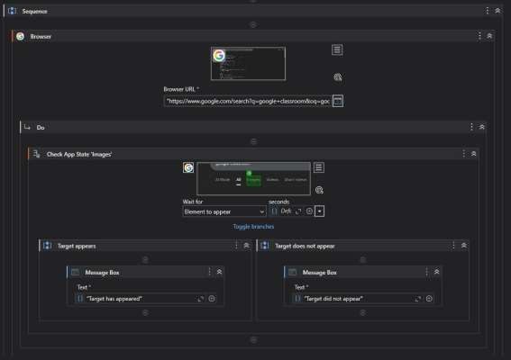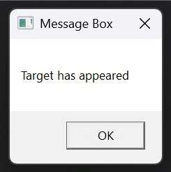

Robotic Process Automation